CHARACTERIZATION

Characterization is the method used by a writer to develop a character. The method includes (1) showing the character's appearance, (2) displaying the character's actions, (3) revealing the character's thoughts, (4) letting the character speak, and (5) getting the reactions of others.
~http://www.tnellen.com/cybereng/lit_terms/characterization.html
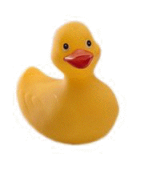
Worksheet on which to create your duck's identify.
Name:

Trait 1 | Trait 2
Trait 3 | Trait 4

Your Name________________________________

