Step 1
- Go to your Google Docs.
- Click on “Create New”… “Form”

Step 2
- Name your form.

Step 3
- Write your questions
Step 4
- Do you want this to be “required” question?
- Click “Done” after each question.
Step 5:
- Want more than two questions?
- Click on “Add item.”
- Choose the type of question you want to ask.
Step 6
- Add a colorful background by clicking on “Theme.”
Step 7
- You have 71 choices!
- Choose one and select “apply.”
- Then click “back to editing.”

Step 8
- Now you are ready to embed your form so that others can answer your questions.
- Click on “More actions.”
Step 9
- Right click and copy the html code.
Step 10
- Where do you want to display your survey/form?
- In your blog, go to your Dashboard.
Step 11
- Click on “Edit pages.”
Step 12
- Click on “New Page.”
Step 13  - Give your page a name.  - Click on “Edit Html.” |  | 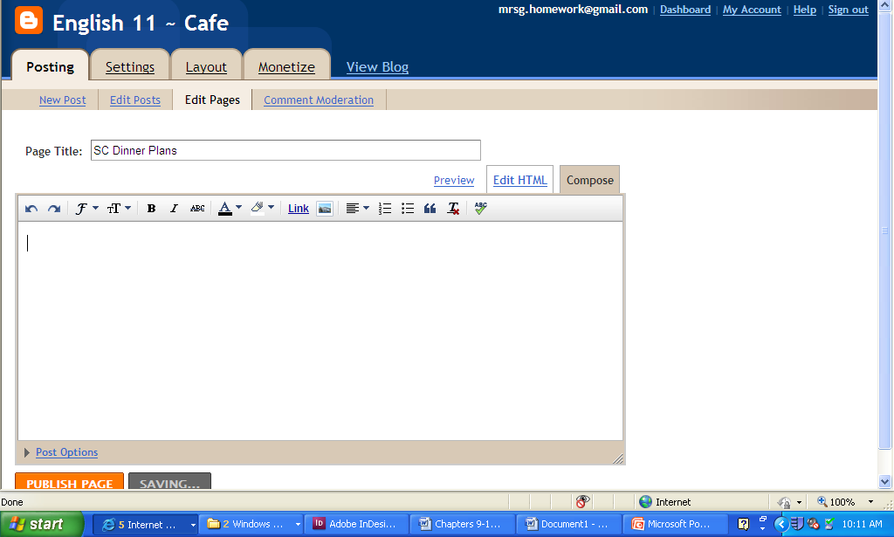
Step 14  - Paste the code into the box.  - Page will automatically save. |  | 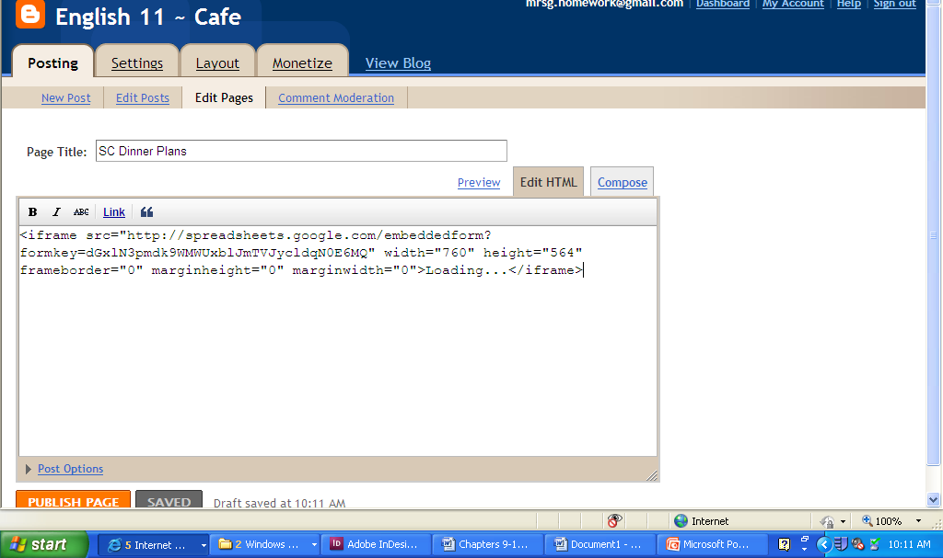
Step 15  - Page will not display on your blog, until you select “Publish Page.”  - Then click on “View Blog.” |  | 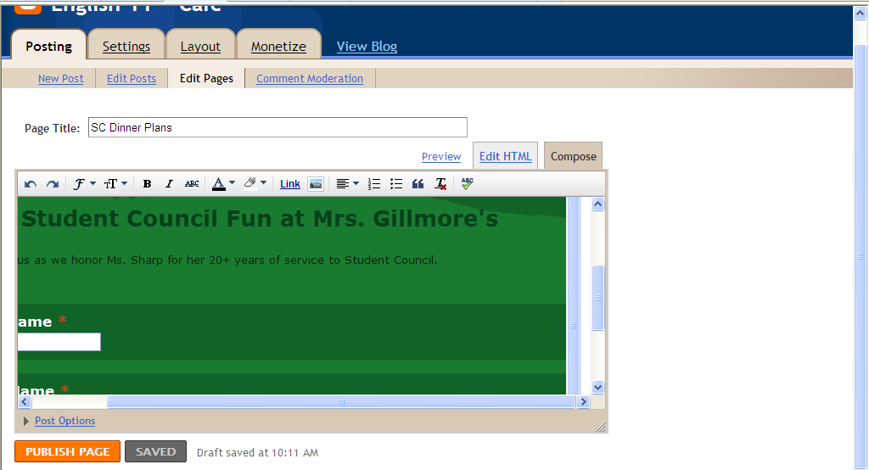
Step 16
- You are now published!
Step 17  - Click on survey button.  - Ta-da! |  | 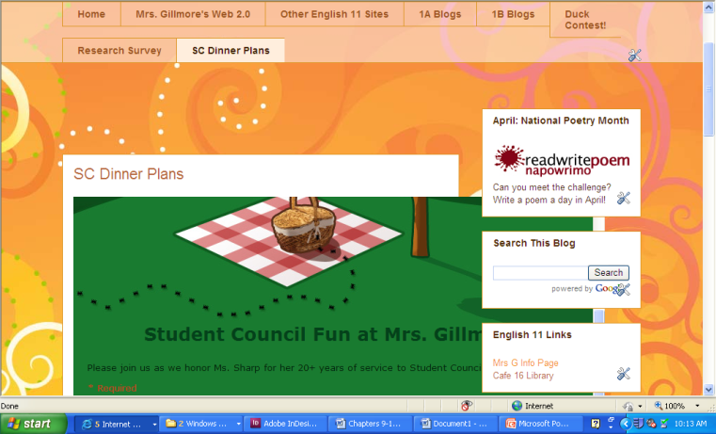
Step 17
- Want to email your survey/form?
- Click on “Email this form.”
- Insert email addresses.
- Click “Send.”
Step 18  - To publish a link on the class wiki, go to the wiki and log in.  - Go to the assigned page.  - Click the “edit” button. |  | 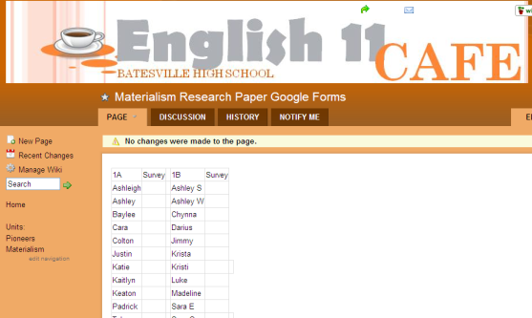
Step 19
- Place your curser where you want to insert the link (by your name!)
- Click on the link button.
- Select “External Link.”
- Type in the link text/title.
- Paste the URL to your blog page in the “Address” line.
- Hit save!
Step 20
- You have now created a “link” to your page on your blog.
- Congratulations!

